Action Takers
Revised June 3rd, 2020

Serendipitous people are more “fearless” i.e. (explorational, courageous, curious and playful) about trying new things
Focus on Positive Potential Outcomes
Instead of worrying about something what could go wrong they think “isn’t that interesting, I’d like to give that try” (contrast this with only focusing on the good things that could happen)
- Focusing on Good Outcomes Increases Self-Sufficiency
- Perpetuates and reinforces the belief that you are competent and more capable of accomplishing whatever you set out to do.
- Tend to be more Competent, Confident and Take More Risks
- Seize Opportunity Where Ever They Perceive It
- Willing to take risks

Mentally Resilient:
- Quickly Brush Off Disappointments and move on to the next opportunity

Happier Disposition:
Action takers by nature are happier because…
- They have a constant influx of new stimulations, experiences and activities in their day to day lives
- Deliberately doing new things automatically boosts contentedness
- Also results in the growth of new brain matter.
- If an opportunity is available, they will usually follow it.

Self-Starting- Big Picture Thinkers
- Almost NEVER Act With 100% Certainty
- Our minds (like our parents) do not always tell the truth
  - Confirmation Bias
  - Loss Aversion Bias
- When truly uncertain about a decision they ask themselves
  - Acknowledge concerns
  - What's the worst that can happen?"
  - How likely is that particular situation to really happen?"
  - Weight short term costs vs long term benefits.
- Follow intuition -but don't expect to feel 100% Certain

If you wait until all negative emotions disappear …
…you will never take action.

Extraverted
Revised June 4, 2020
Note: This form of extraversion varies a bit from the commonly accepted definition of extraversion as per Myers Briggs Type Indicator and other personality profiling instruments.
Tend to have a much more outgoing personality.
- Seek more opportunities for social contacts as opposed to
opportunities for solitude.
- They reach out to the world so the world reaches out to them.
- A lucky person’s direction of attention is out in their external world
- An average or unlucky persons direction of attention is in their internal world

Tend to Have Larger Circle of Friends and Acquaintances
- Increases Chances of fortuitous referrals and opportunities.
- Perceptual Filters Zero in On These Elements

Lucky people will perceive (and act upon) "chance encounters in the environment that unlucky people will not.

Identity
Revised June 4, 2020

Lucky people self-identify as being lucky

- They have a belief at the identity level that they are lucky people
- Their nervous system and UC sorts for elements in the environment that reinforce and take advantage of that label
- Therefore, they are far more likely to have fortuitous encounters than those who label themselves average or unlucky

- What you believe influences what you perceive

  - Review of luck studies and perceptual filters

Logical Levels of Belief
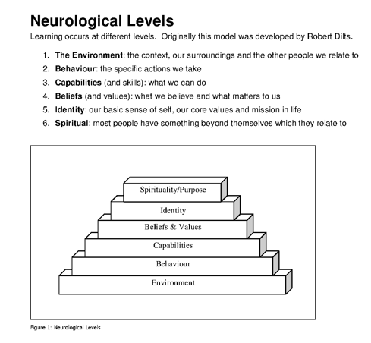

Kind to Themselves
Revised June 4, 2020
Lucky people do not beat themselves up over mistakes or failures
- Recognize that failures are a stepping stone to better things:
- Don’t take themselves quite as seriously as unlucky people do
- Lucky People Are Highly Resilient
  - Most Successful Business People Were Once Failed Business People
  - Brush Off Failures and Disappointments and quickly move on to the next opportunity
- They know how to let the past go and move forward
- More present and Future Oriented Rather Than Past Oriented.

They go for the fortuitous moments and are not put off by a couple of setbacks along the way.

Grapho-Analysis/Grapho-Therapy: Red Flags
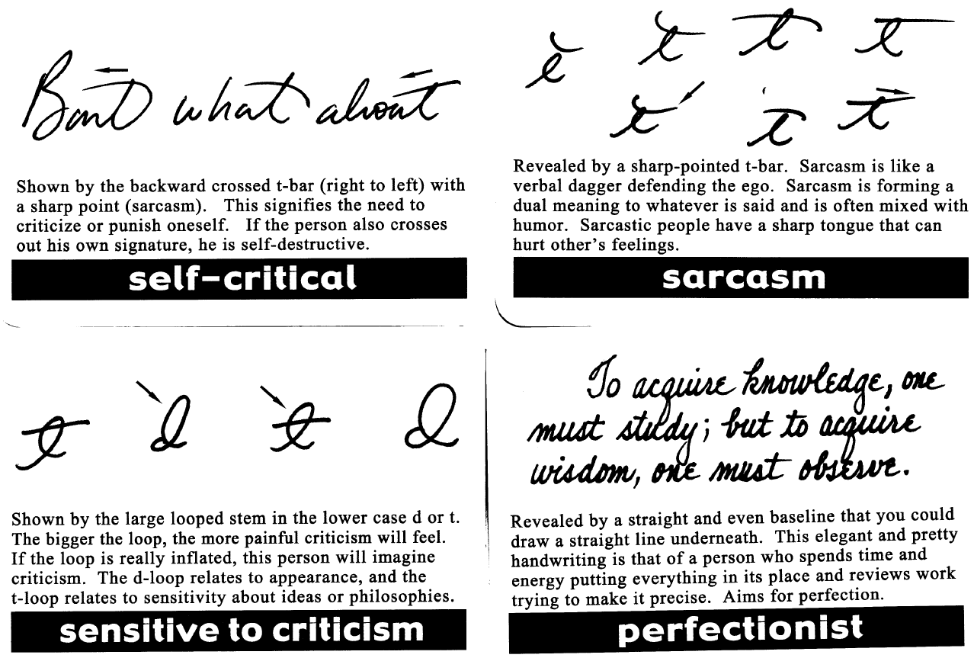

Open Minded
Revised June 4, 2020

Flexible and Adaptable to Life’s Changing Circumstances Go with the Flow

Specifically - Vague
Revised June 4, 2020

Focus on Destination and let the method and means take care of themselves
- Bullet Pointers Rather Than Scripters
- Avoid hyper specificity when selecting a direction
- Vowing to become a doctor who helps people vs cardiac surgeon at the mayo clinic

Mind Set Comparison
Revised June 4, 2020

Think Lucky To Be Lucky…

Domain: | Avg | Lucky
Romantic | Here is my checklist  They have to meet these criteria  - Smart,  - Attractive,  - Financially secure,  - Subscribe to the New York times,  - Love to cook  - and must love dogs | - I don’t really have a type  - I’m open to anyone as long as they are a good person.  - I'll know it when I see it.
Work | - I need to finish this project  by 11  - Team meeting at 12  - Finish that report by afternoon  - Home by 6 pm | I want to try to accomplish two major things today…  But in my downtime, I'm going to explore a few other ideas that could help the company or my career
Friendships | - I already have a handful of friends  - I don't need or have time for any more | - I love to make new friends.  - Even if it never goes farther than a conversation or a Facebook friending.
Errands | - I need to hit the dry cleaners  - The bank  - The grocery store  - I should be home in time for game | I have to get these things done…  …but I am not going to rush because I don't really know what to expect or whom I will meet.  It will be interesting to see how it works out.
Business Meeting | I'm meeting up with this person to do a deal, not thinking of them as a friend or a potential partner | I'll accept a meeting with anyone any time, because you never know where is might lead - even if it’s five years down the road.

Vibrational Energetics:

Thoughtforms:

Two Ways Thoughtforms are created.
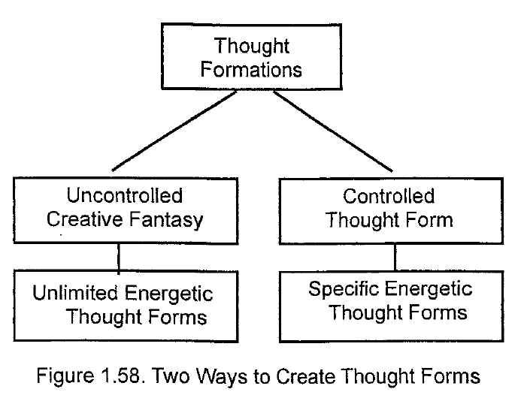

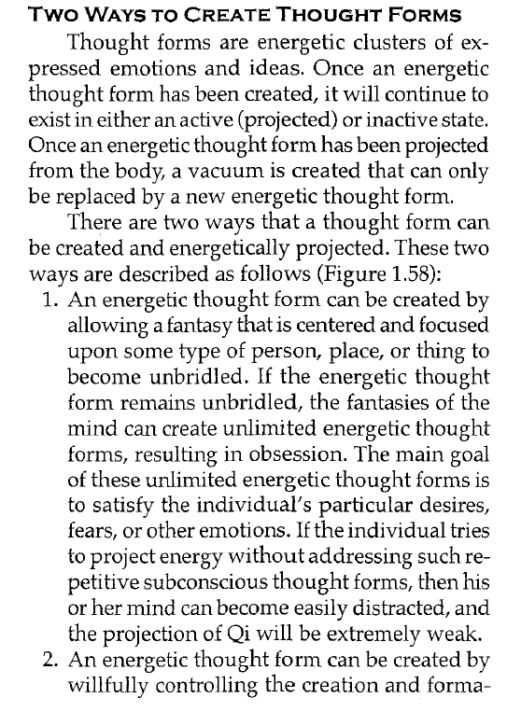
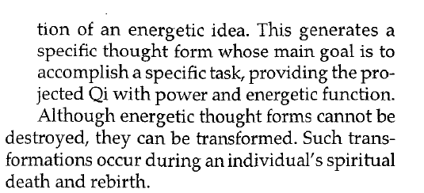

Anatomy of a Thoughtform

